Date: ___________________ Name: ___________________________________

LABORATORY EXERCISE 0
GETTING FAMILIAR

OBJECTIVE: To become familiar with the simulation software.

1. RUNNING THE PROGRAM

Run PC-ControLAB.
In the installation folder, locate and read the file “QuickStartGuide.pdf”.
Slow down the simulation speed via View | Scroll Rate and select a mid-value, to have a more practical experience.

2. THE FEEDBACK LOOP

Click Control | Retrieve Strategy, Model and Tuning then select “Feedbck1”
(in C:\Users\Public\PC-ControLAB 3.1)
Note that the simulation starts with an initial controller output (OUT) of 35%. You can press
PAUSE at any time and use the cursor to read the values. To rerun the simulation, press RUN.

What is the process variable (PV) current value? 275
What is its range? From 0 to 500 DegF
What is the controller output range? From 0 to 100%

What is the setpoint (SP)? 275 DegF

With the controller in MAN, set the controller output to 20%. Observe the process behavior.
Note that the continuously scrolling display records the previous 60 (simulated) minutes of the response, and that you can’t retrieve the trend that scrolls past the left display border.

Can the process be described as static or dynamic? dynamic

At which value does PV settle to? 162.50
After how long does PV appear to settle at this value? 30 Minutes
Calculate the time elapsed since the controller OUT was changed to the time the PV becomes reasonably close to its final value (the usual definition of “reasonably close” is when 98% of the change has occurred).

Change the LOAD by pressing StepIncr or StepDecr twice in rapid succession.
What do you observe?
The PV decreases and because we are in manual mode the OUT doesn’t change

Switch the controller to AUTO.
Does the controller bring the PV back to the setpoint? Yes but after a lot of time and there was hunting in more than 2 clock cycles
Increase SP to 350 degF. Observe the response.
Does it exhibit more time variability or less compared to the process response with no feedback (i.e., when the controller was in MAN)? It exhibits more variability. In Manual, the PV smoothly decayed to a new value without oscillating. In Auto, the controller fights the error, causing the PV to swing up and down repeatedly till it settles.
Do the oscillations die out? yes
If so, we call them DAMPED oscillations

Does the PV reach the new SP? Yes , PV=348.

In how many cycles? ______________________

What is the PV overshoot? ______________________
(see Figure 1 at the back of this exercise)
What is the period of oscillation? ______________________

Does the controller do a good job? ______________________

(For a damped response, the industry standard is that a well-tuned controller will bring the PV to the SP in at most one cycle and with an overshoot not exceeding 5%)

Change the LOAD by pressing StepIncr or StepDecr twice in rapid succession.
Does the controller manage to bring the PV back to the setpoint?
______________________
Switch the controller to MAN. Allow LOAD to fluctuate like real life situations (AutoLoad). Try to keep the PV as close as possible to the SP (keep changing the controller output up and down for few minutes).
How easy is this task? __________________________________________

While LOAD is still fluctuating, switch the controller to AUTO.
Observe PV fluctuations around SP for some time. Do they seem to be acceptable for operation?
i.e., confined within a relatively small range (say 1% or even 2% of the PV range)? _____________________________________________________________________________

Switch off AutoLoad. Keep the controller in AUTO. Change the controller tuning parameters such that PV exhibits sustained (UNDAMPED) oscillations. Hint: click TUNE then increase the controller gain. Record this gain.
Gain = ______________________

Reduce the controller gain to 0.1. Change the setpoint again.
What do you observe?
_________________________________________

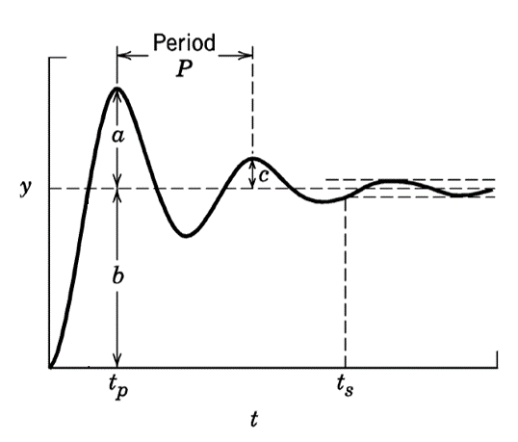

Figure 1 DETERMINING RESPONSE PARAMETERS

Overshoot: OS = a/b %

